Lesson 8 – Mass Upload from Power Platform to SAP



Exercise 18: Import solution and update menu system and drop downs for Power App 2
Part 1: Import Solution 2

Exercise 18: Import solution and update menu system and drop downs for Power App

Part 1: Import Solution
- Open your Power Platform Maker Portal. Go to https://make.powerautomate.com using your new credentials supplied by the instructor.
- Select the correct environment. In the upper right-hand corner, click on the Environment and select the correct environment for this lab based on the information supplied by the instructor.
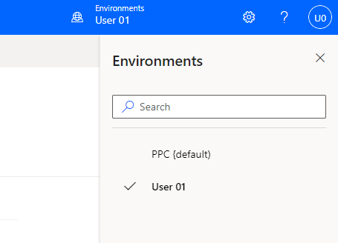

- We will create 2 Connections before importing the solution. On the left-hand side, click More and then select Connections. You may need to scroll down or click Discover all if you don’t see Connections.
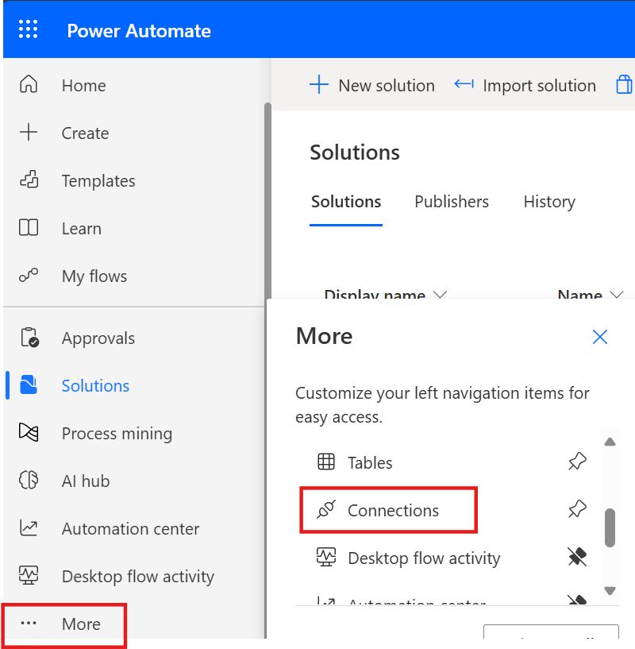

- Click + New Connection.
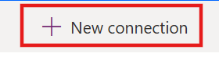

- Search for OneDrive for Business and select that Connection.
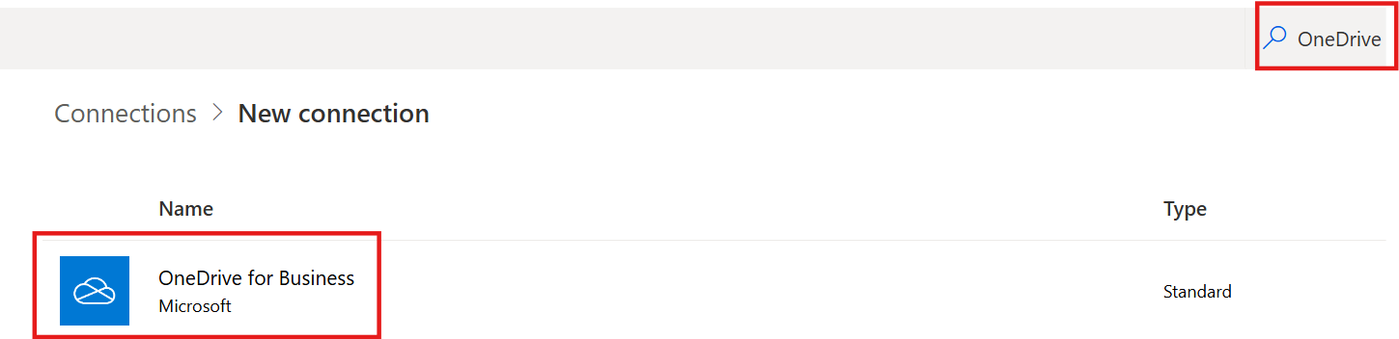

- Click Create.
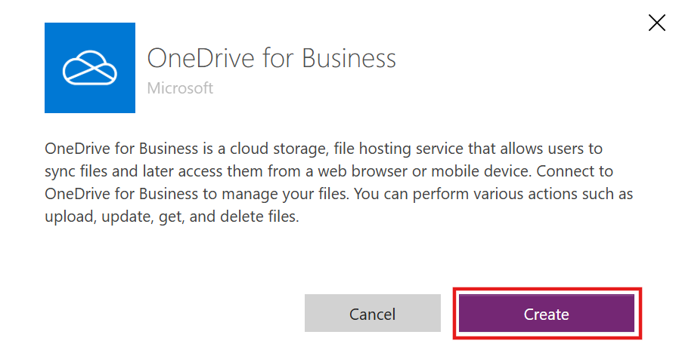

- Sign in with your M365 lab credentials.
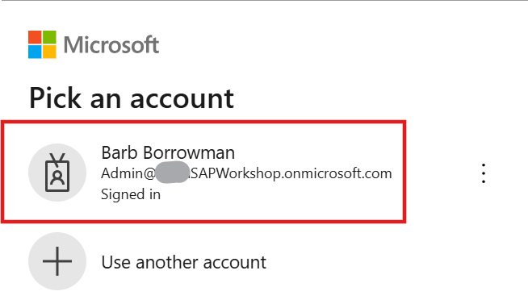

- Click + New Connection.
- Search for HTTP and select HTTP with Microsoft Entra ID (preauthorized)

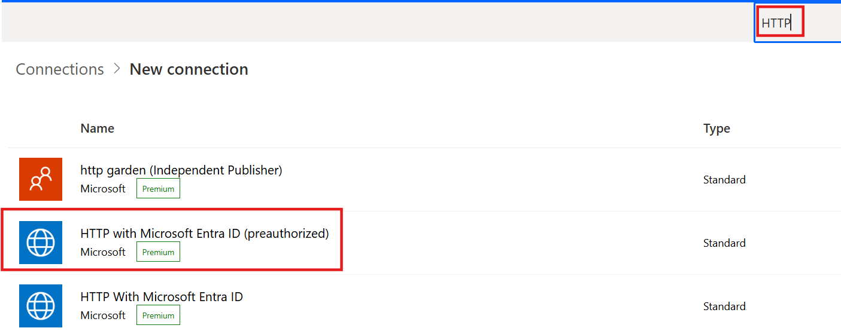

- You will need to get the environment URL for the configuration of the connection. Open another tab in this session so you are still logged in with your lab credentials and browse to aka.ms/ppac. Click on Manage and then select the environment you are working in for the labs.
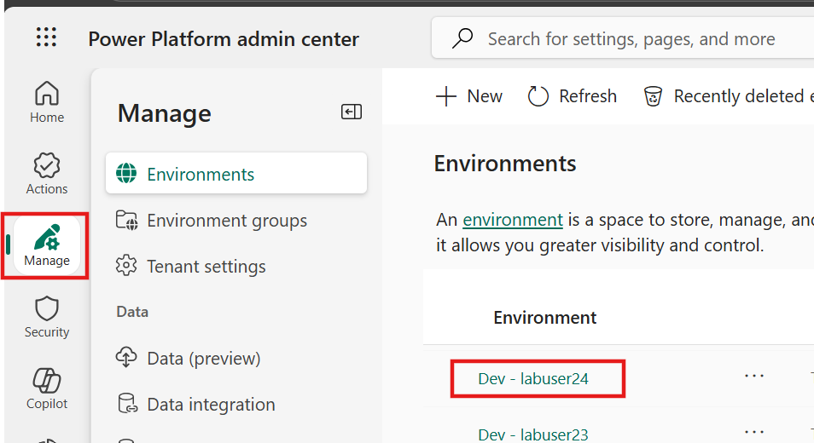

- Copy the Environment URL.
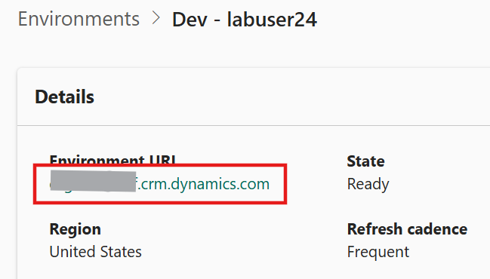

- Click back to the tab where you are setting up the connection. Keep Authentication type as Login with Microsoft Entra ID. For the Base Resource URL and the Microsoft Entra ID Resourse URL, copy the environment URL and prefix with https://. Click Create.

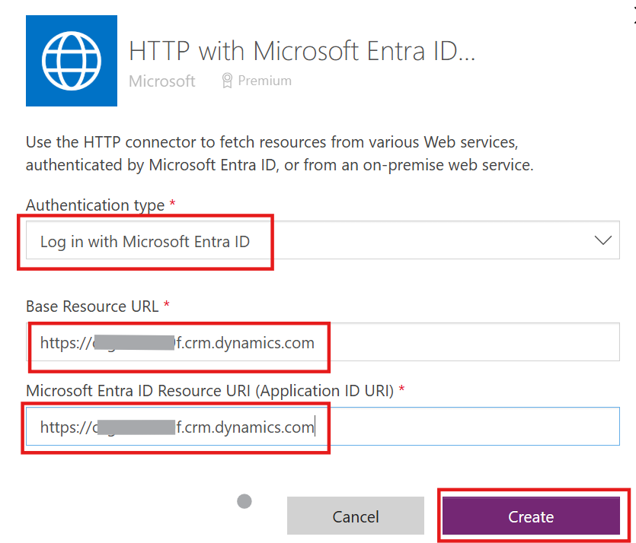

- Sign in with your M365 lab credentials.

- We are now ready to import the solution. Select the Solutions Tab and click on Import Solution.
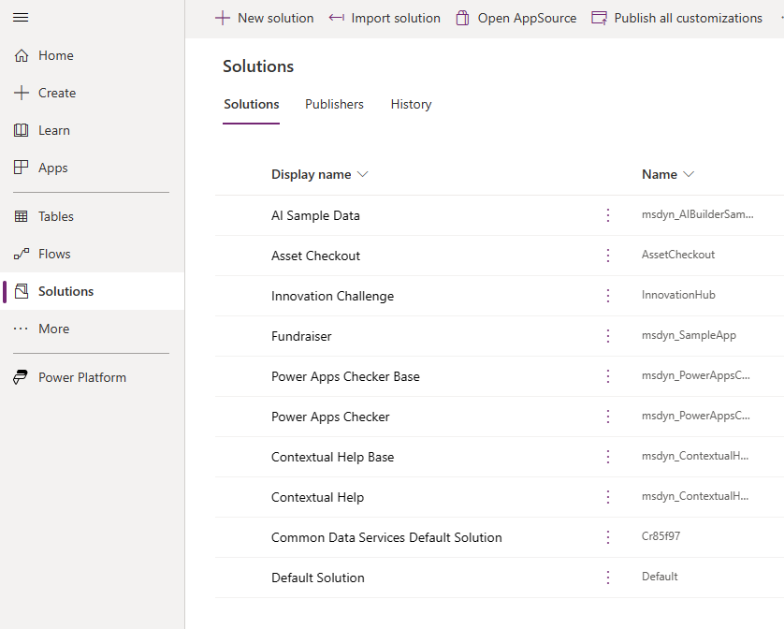

- Click on Browse and select the SAPJournalEntries solution. The file is located in this GitHub Repository. After you have selected the file, click on Next.

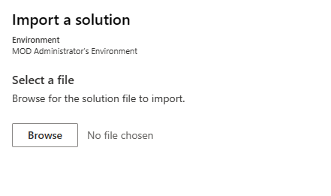
- Then hit Next and then Next again.
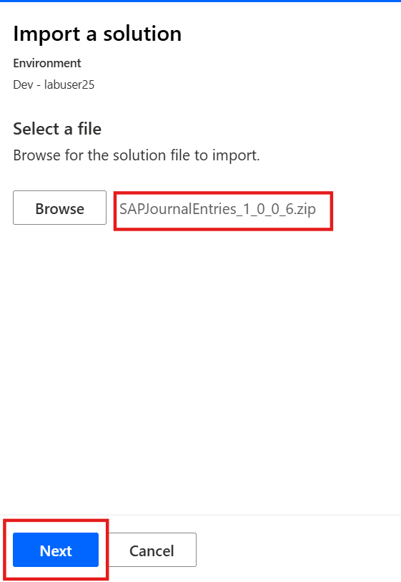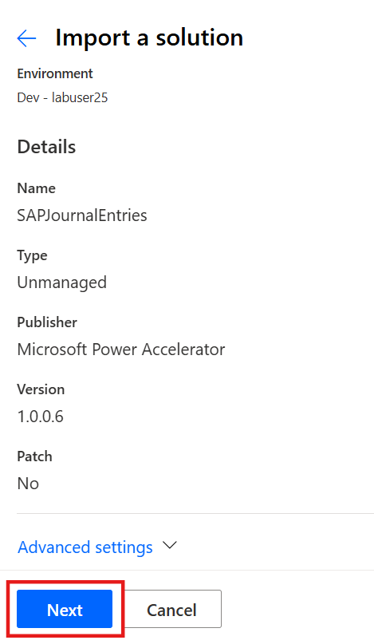
- Scroll through all the connections and confirm they have green check boxes to confirm you have valid connections, then click Next.

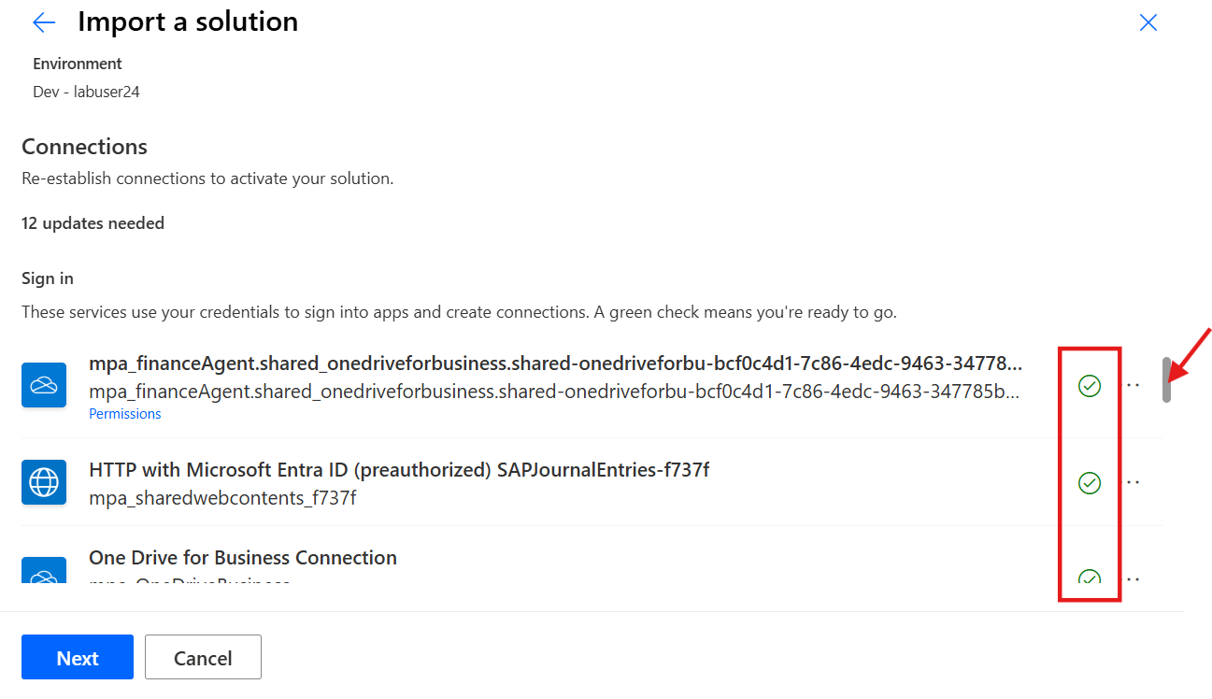

- Configure the Environment variables based on the information below and then click on Import. You should only have to change the SAP Application Server.
Mass Upload URL: Keep the same, we can change after import to match your PowerApp.
SAP Count of Rows To Read: 1000
SAP Client ID: 800
SAP System ID: ABA
SAP Language Key: EN
SAP Application Server:
{"AppServerHost" : " 10.0.1.203", "LogonType":"ApplicationServer", "SystemNumber": "00", "Client":"800"}

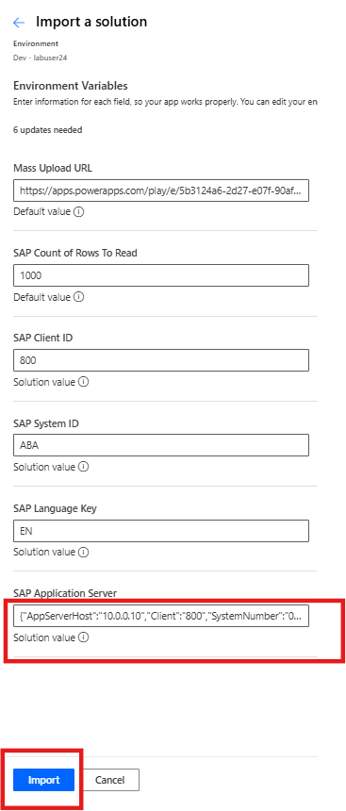

- It will take a few minutes to import the solution and you will see a message in the top ribbon that the solution is being imported.
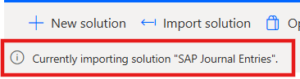
When you see the solution has successfully imported, you can move onto the next step.

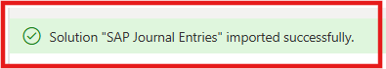

- Please confirm that all the cloud flows we imported with the solution are turned on. Click on the SAP Journal Entries solution, filter on Cloud Flows and ensure all have a status of On. If not, click on the flow and click Turn on.
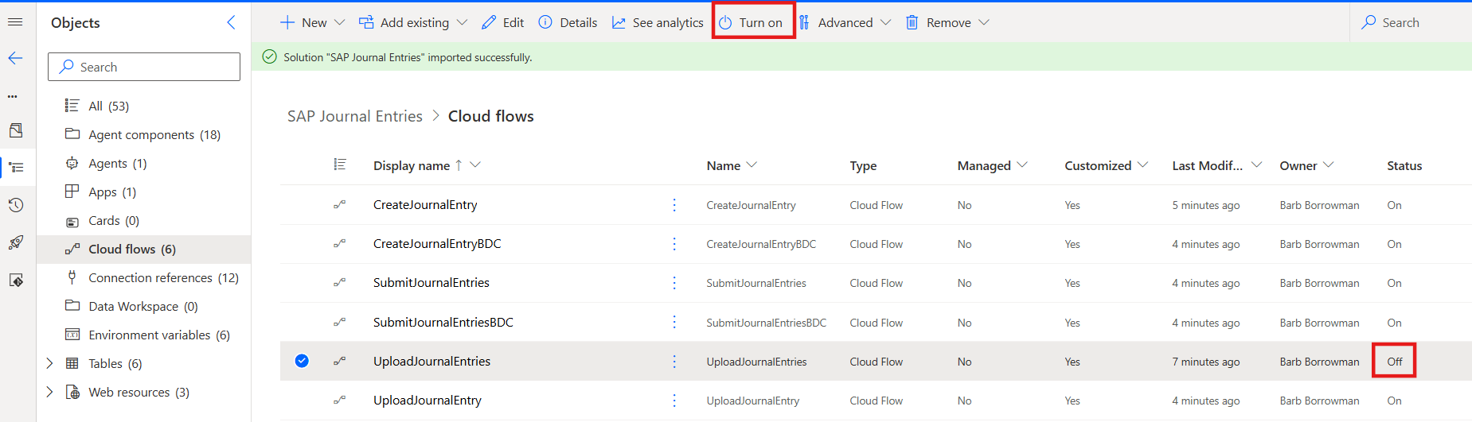

- We will need to make a couple of changes to the UploadJournalEntry flow. Click on the ellipse (…) for the UploadJournalEntry flow and click Edit.
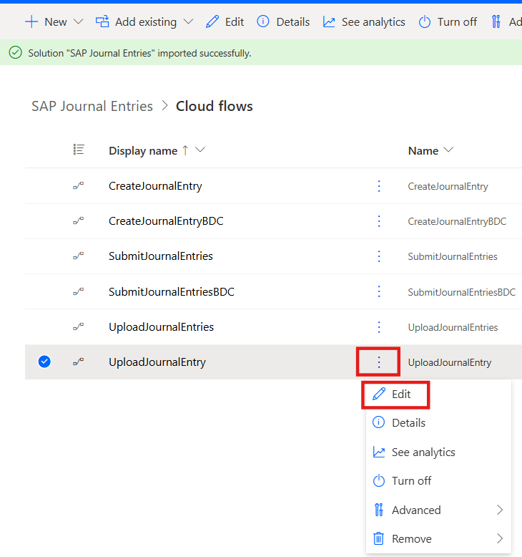

- We need to update the document library for our OneDrive for Business. Expand the Get Header action and clear the current Document Library.
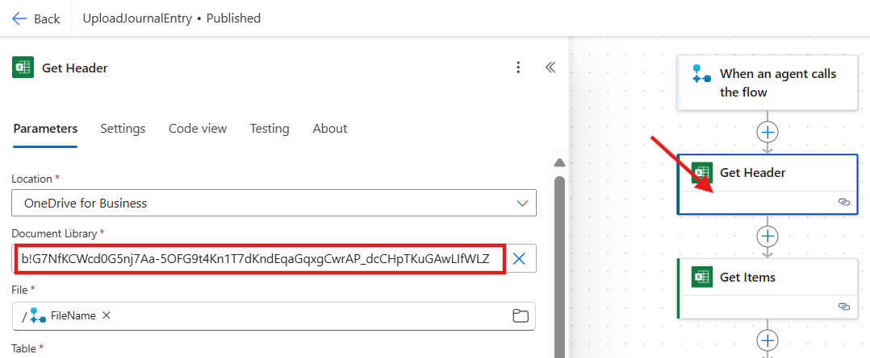

- Re-select OneDrive for Business for the Location and then select OneDrive from the Document Library drop-down list. If you don’t see anything in the drop-down list. Select a different Location and then re-select OneDrive for Business again.

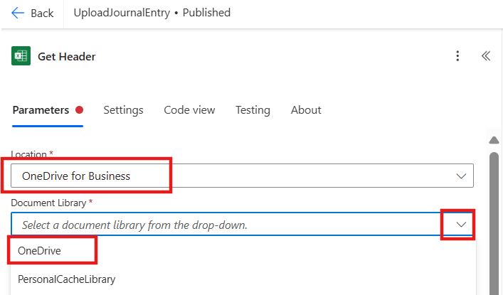

- Do the same steps for the Get Items action.
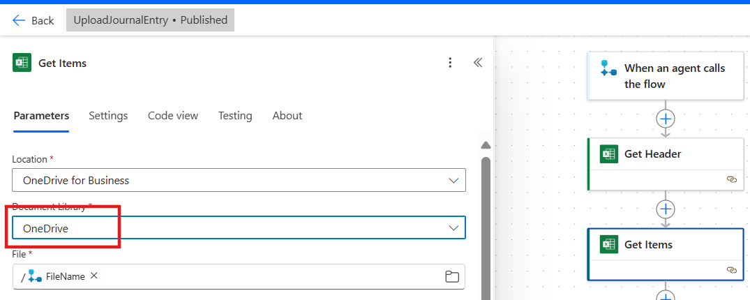

- Save the flow. Click on Save draft in the upper ribbon and then Publish.
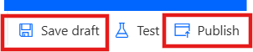

- We are now ready to test the Finance Agent. Open a new tab in the same browser session so you are still using your lab credentials. Browse to copilotstudio.microsoft.com. Select the correct environment and click on Finance Agent to open it.

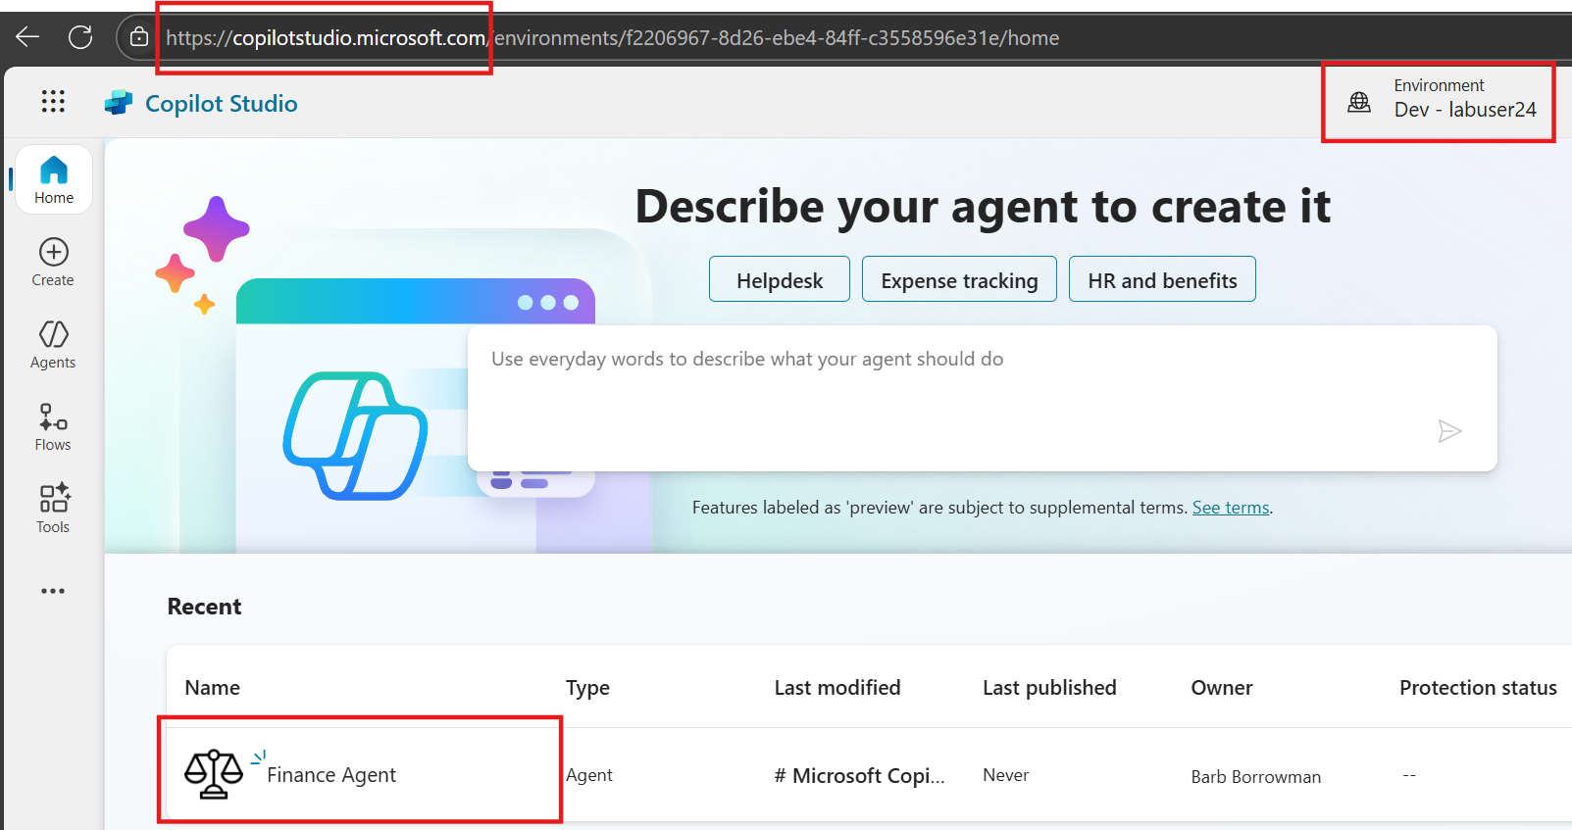

Alternatively, you can click on the Finance Agent in your solution in Power Automate.
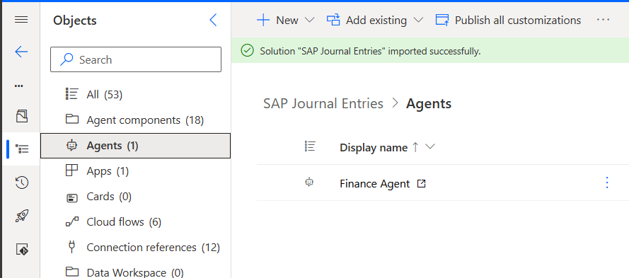

- In the test pane, type Upload Journal Entry and hit the Play button.

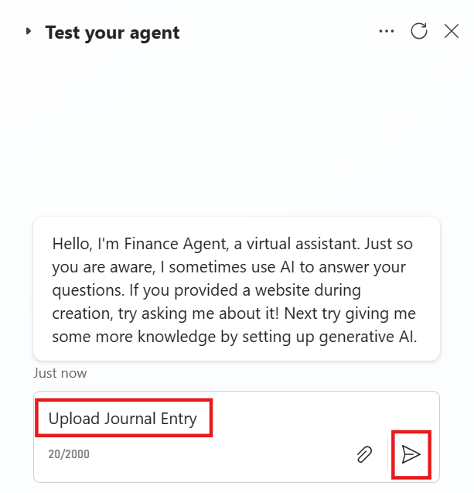

- Click on the Paperclip to attach the Delta Workshop Sample Data Excel file from the lab resources and then hit the Play button.
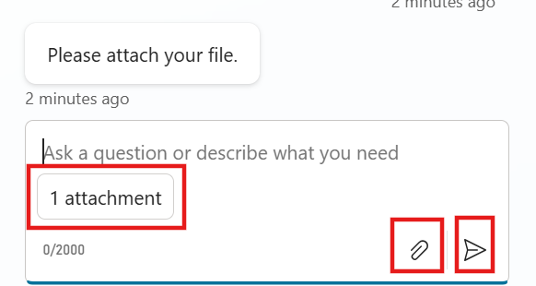

- You will see a message with the number of line items. You can either Send to SAP via API or Send to SAP via GUI.
  - Send to SAP via API triggers the SubmitJournalEntries flow and changes the status in the SAP Mass Update table to “Submitted”.
  - When a new row is added to Dataverse the CreateJournalEntry flow is triggered. It is filtering for any rows that have status of “Submitted”. The flow creates the Payload for the SAP BAPI and then calls the BAPI ACC Document Post to upload to SAP. If successful, the status in the SAP Mass Update table is changed to “Posted”. When the batch has completed, an email is sent out to the user.

  - Send to SAP via GUI triggers the SubmitJournalEntriesBDC flow and changes the status in the SAP Mass Update table to “Submitted”.

  - When a new row is added to Dataverse the CreateJournalEntryBDC flow is triggered. It is filtering for any rows that have status of “Submitted”. The flow creates the Payload for the RFC Call Transaction Using action and builds out all the keyboard clicks.

- We can add the Teams Channel to the Agent to have it available for interaction in Teams.

